Face matching
Practicum Computational Vision

Authors Pablo Martínez
Aleix Solanes
Delivery 12th January 2016

Exercise 1

- Explain which is the result showed in the Matlab Figures in Figure 1 below.
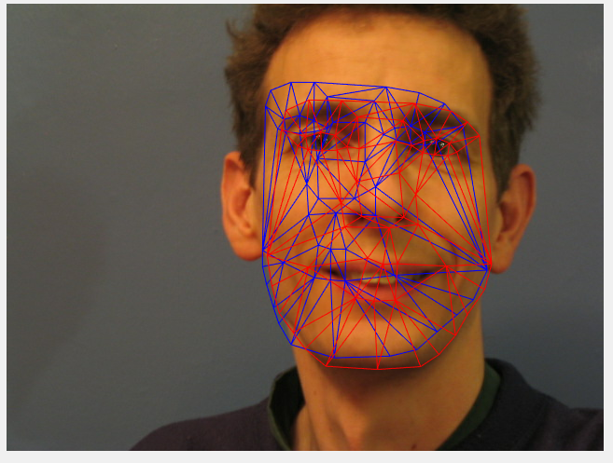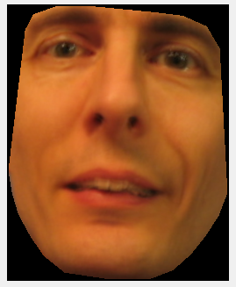
The first one shows a blue mash which is a random initial shape from the training set of shapes. The red mash is produced by fitting using an Active Appearance Model algorithm, it is considered as the result of the fitting algorithm.
The second image is the fitted appearance into the given image (the reconstructed appearance).
- Explain how the 'Number of Shape Modes' and the 'Number of Appearance Modes' are computed in the function build model 2d.m.
The number of Shape Modes is the number of principal components which in fact are the number of eigenvectors of the covariance matrix. The PCs are taken by getting modes that cover the 98% of the variation.
The Number of Appearance Modes is computed as the number of PCs which it is the number of eigenvectors of the covariance matrix for the appearance data for reaching a 98% of total variation.

Exercise 2
Implement the following changes in the code:

- In the script _t2d test complete.m, change the selected test image from '3' to '10' and save the resulted figures.
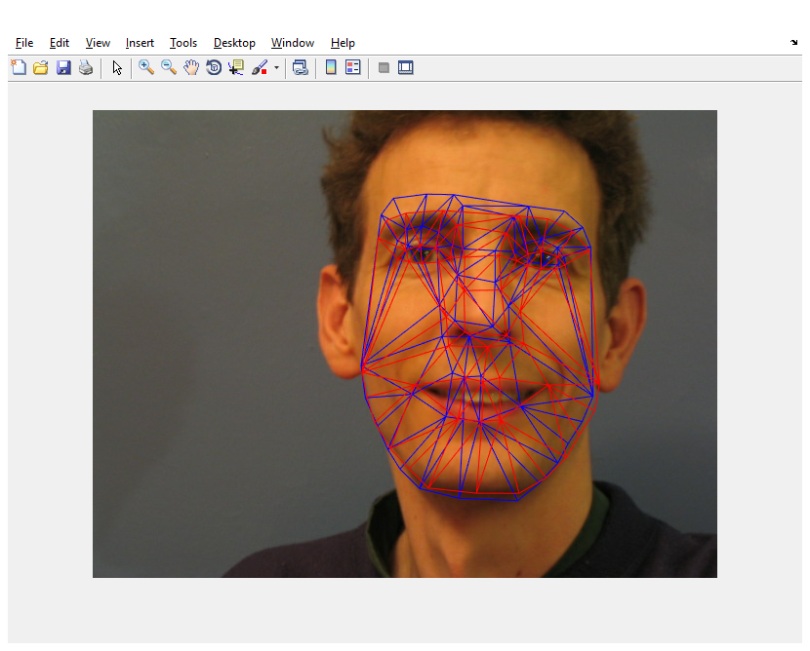
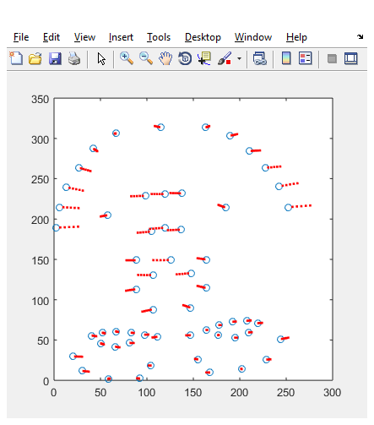

- In the function build model 2d.m, build two images with all the training shapes before and after the alignment using Procrustes Analysis. As it is done in the Figure 2 below. Use the function triplot.m with the matrix 'shape triangles' as the _rst argument.

